Press Release
July 2020
The Secret Side-hustle That’s Made Savvy Millennials Millions During the 2020 Lockdown
- Over half of Americans (56%) have cleaned out their closets and drawers to make more space in recent months during lockdown
- Millennials are earning an average of 25% more on each item they sell compared to other generations
- Americans in Florida, New Jersey, Pennsylvania, Georgia and North Dakota are the highest earning side-hustlers while those in Mississippi, South Dakota, Iowa, Maine and Montana rank at the bottom
- Apple computers and cell phones are the most lucrative items, making millennials over half a million in just a couple of months
While the U.S. lockdown has posed many challenges when it comes to health, relationships and work, a recent trend rising amongst the millennial generation indicates that many are finding creative means to make extra income while stuck at home.
According to internal data from leading U.S. tech reseller, Decluttr, trade ins of Americans’ old tech items have increased by 24%, with cell phones having seen a huge increase of 36% compared to 2019, demonstrating a clear uptick in the trend of reselling.
While over half of Americans (56%) have cleaned out their closets and drawers to make more space in recent months during lockdown, Millennials are proving to be best side hustlers of all, being more likely than any other generation to have resold the unused items they’ve discovered while decluttering for extra income.
Millennials are also earning an average of 25% more on each item they sell compared to other generations, indicating that they’re selling their unused tech off quicker and are therefore getting a better return for it.

The most lucrative items for this generation to be selling back are Apple computers and cell phones – which made them well over half a million in just a couple of months.
Gen-X turned to their old DVD collections, having sold off nearly 200K CDs, DVDs and Blu-rays - items that were nearly obsolete in the lives of the younger generations.
The younger Gen-Zers on the other hand, were surprisingly the least likely to trade-in their old items – arguably as they’ve had less years to build up a pile of unused tech. However, they were seen to be selling their video game consoles on mass, making twice as much as the average across other generations.
When looking at the top side hustlers across the U.S., residents in Florida, New Jersey, Pennsylvania, Georgia and North Dakota top the list of those making the most per capita, whereas residents in Mississippi, South Dakota, Iowa, Maine and Montana rank at the bottom for money they’ve made from selling their unused tech and media.
While banned from their regular beach visits, Florida residents are spending their time cashing in on old tech, earning 62% more money overall per resident compared to other states, trading in 37% more items per resident and making 23% more money on average per device. Most notably, Floridians are getting among the highest returns on Apple computers, which they’re selling for more than twice as much per unit compared to residents in other states, indicating that they’re taking action early to get the best value.
The following map shows which states’ residents have proven to be the best at making the most off their unused technology items. States are ranked based on overall money earned from tech trade-ins per resident compared to the nationwide average using Decluttr’s internal trade-in data applied per capita using U.S. census population data per state.
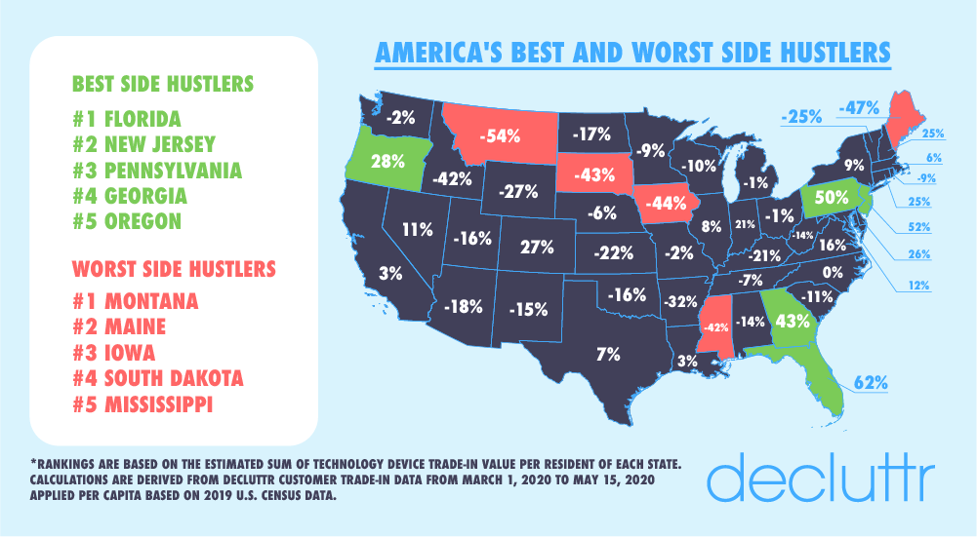
North Dakotans and Georgians, meanwhile, are earning the highest return across all other states on their mobile phones, earning $40-$50 more per trade-in on their old phones compared to the average state resident, and $90-$100 more than the residents in the states with the lowest average trade-in values for mobile phones, Maine and Idaho.
The bookworms of the U.S. are located in Pennsylvania, Arkansas, Rhode Island, North Jersey and South Dakota, where residents are turning over 2-3 times more books per resident than people in other states in the U.S.
While many may consider their old DVDs, Blu-rays and CDs of little value, Decluttr data proves otherwise, with some residents trading in their old DVD and Blu-ray collections for more $500 in trade-in value. Residents in Arkansas, Maine and Rhode Island in particular appear to have the most “valuable” taste in movies and music, earning the most per items for their old DVDs, Blu-rays and/or CDs while residents in the northeast are the most active at trading in their devices, with residents in Pennsylvania, Massachusetts and Connecticut trading in more than any other state per capita.

Yet, despite the many who are reselling or donating their unused items, 35% of Americans say they typically just keep their unused tech in their homes and 12% typically throw the items away, indicating a huge financial opportunity for Americans who aren’t capitalizing on the resale value of their old technology items.
Gen-Xers and Boomers overwhelmingly admit to creating more waste in recent months as a result of re-organizing and/or cleaning out their homes and many older Americans admit to holding onto unused technology items nearly twice as long as their younger counterparts, which has historically led these items to depreciate in value by 26% over the course of a year.
“Given many Americans have been cleaning out their homes and workspaces in recent months, we’d encourage them to think about the potential value of every unused item they’ve found and reconsider whether to hold onto it or toss it” said Liam Howley, CMO of Decluttr.
“We’ve been shocked to hear how many think their old items have no value, but we’ve been encouraged to see more people starting to sell their old items and we hope that others will follow. Allowing old tech items to be refurbished and repurposed not only provides an extra source of income, but it contributes towards a circular economy which reduces the need for production of new technology hardware, which many don’t realize has a serious and harmful impact on the environment.”
For those looking to clean out their old technology items throughout their homes, the following chart shows how much others have received, on average, for their old tech items:
Device Type | Average Trade-in Value
Apple Computer |  | $562
Apple TV |  | $62
Blu-ray |  | $1.44
Books |  | $1
CD |  | $0.82
Cell Phones |  | $197
DVD |  | $0.78
Games Console |  | $0.78
iPod |  | $51
Kindle |  | $15
Tablets |  | $323
Video Games |  | $9.20
Wearables |  | $93
Apple Computer |  | $562

-ENDS-
About Decluttr
Decluttr was brought to the US in 2014 by global re-commerce leader musicMagpie, the biggest third-party seller in the world on Amazon and the first company in the world to pass ten million in eBay feedback. Decluttr.com is a fast, easy and free way to sell tech and media such as smartphones, tablets, wearables, CDs, DVDs, games, books, LEGO® and more, as well as to purchase refurbished tech and media.
Decluttr offers customers a better value and more sustainable option when purchasing and trading-in their tech, that is ‘Smart for you and Smart for the planet’. It refurbishes 95% of the products it receives from its customers, and if it can’t refurbish them, the majority of their parts will be reused to refurbish other products. Its business practices promote a circular economy model and it is proud to support the reduction of e-waste globally, as well as the reduction of mining for precious metals used in new tech.
The service removes all of the stress of selling unwanted items online. All customers need to do is visit the site or download the app, enter the barcode of the item or scan it, get an instant price, pack into any box and ship them for free to Decluttr.

Thanks to Decluttr’s fast next day payments, customers get paid the day after their items arrive by direct deposit, PayPal or check – or they can even donate the money they make to charity. To date, the site has paid more than $300M to over 6 million customers - and the service is growing faster than ever.

Decluttr.com been featured on Good Morning America, ABC News, Fox News, The Penny Hoarder, Fast Company, The Wall Street Journal and much more.

For more information, visit www.decluttr.com.

